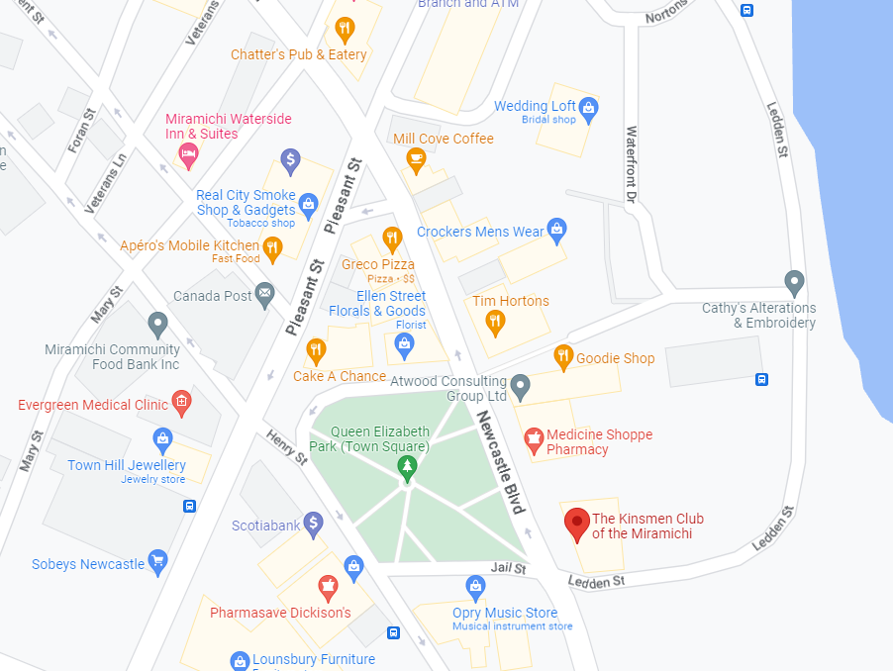

[Chatter’s Pub & Eatery](https://www.facebook.com/chatters.pub.eatery)  
[Mill Cove Coffee](https://www.facebook.com/millcovecoffee2015/)  
[APÉRO'S Mobile Kitchen](https://www.facebook.com/aperosmobilekitchen)  
[Greco Pizza](https://greco.ca/)  
[Tim Hotrons](https://locations.timhortons.ca/nb/miramichi/122-newcastle-blvd)  
[Goodie Shop](https://www.facebook.com/profile.php?id=100083820293773)